# Lab: Arrays

Problems for in-class lab for the [Course instance - JS Fundamentals - May 2019](https://softuni.bg/trainings/2343/js-fundamentals-may-2019)   
Submit your solutions in the SoftUni judge system at: [Arrays-Lab](https://judge.softuni.bg/Contests/1243/Arrays-Lab)

## Sum First and Last Array Elements

Write a **function** that receives an **array of strings** and prints the sum of first and **last** element in that array.

### Examples

|  |  |
| --- | --- |
| **Input** | **Output** |
| ['20', '30', '40'] | 60 |
| ['10', '17', '22', '33'] | 43 |
| ['11', '58', '69'] | 80 |

### Hints

Use the Number function.

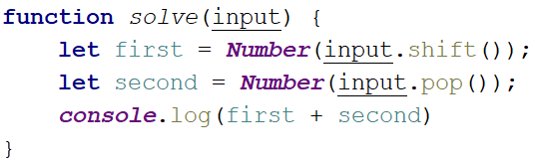

## Day of Week

Write a program which receives a **number** and prints the corresponding name of the day of week. If the number is not a valid day, print '**Invalid day!**'.

### Examples

|  |  |
| --- | --- |
| **Input** | **Output** |
| 3 | Wednesday |
| 6 | Saturday |
| 11 | Invalid day! |

### Hints

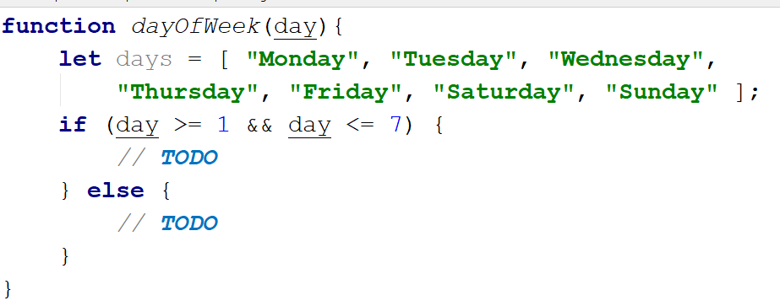

## Reverse an Array of Numbers

Receive a number **n** and an **array** of elements, **create** a **new** array with **n** numbers, **reverse** it and print its elements on a single line, space-separated.

### Examples

|  |  |
| --- | --- |
| **Input** | **Output** |
| 3, [10, 20, 30, 40, 50] | 30 20 10 |
| 4, [-1, 20, 99, 5] | 5 99 20 -1 |
| 2, [66, 43, 75, 89, 47] | 43 66 |

### Hints

Use **push** to add elements inside the new array.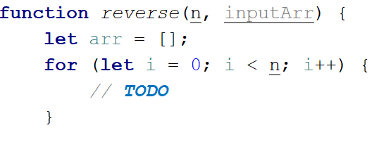

Use **string interpolation** for the output.

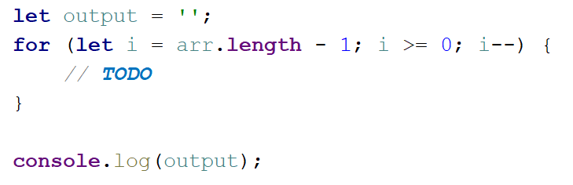

## Reverse an Array of Strings

Receive an **array of strings** (space separated values), reverse it and print its elements. **Swap** elements. For example the **first element should be last** and the **last element should be first** etc.

### Examples

|  |  |
| --- | --- |
| **Input** | **Output** |
| ['a', 'b', 'c', 'd', 'e'] | e d c b a |
| ['abc', 'def', 'hig', 'klm', 'nop'] | nop klm hig def abc |
| ['33', '123', '0', 'dd'] | dd 0 123 33 |

### Hints

Loop to the **half-length** of the array. Create a **function** to swap **two elements** inside an array.

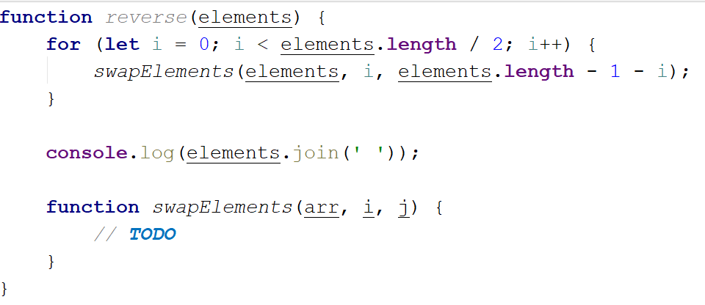

## Sum Even Numbers

Receive an **array of strings** parse them to **numbers** and sum only the **even** numbers.

### Examples

|  |  |
| --- | --- |
| **Input** | **Output** |
| ['1','2','3','4','5','6'] | 12 |
| ['3','5','7','9'] | 0 |
| ['2','4','6','8','10'] | 30 |

### Hints

First, we receive the **array of strings** and parse to numbers.

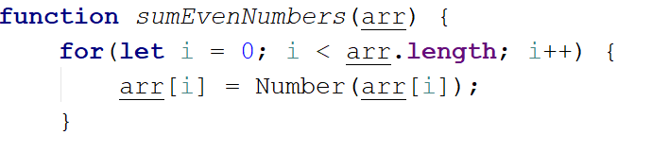

We will need a variable for the sum.

wH1zbzT

Iterate through all elements in the array with **for-of** loop.

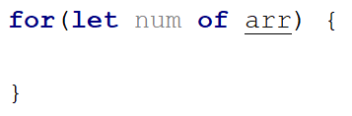

Check if the number is even.

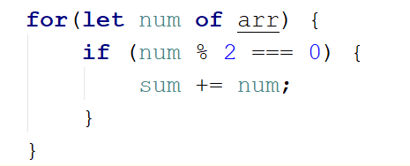

Print the total sum.

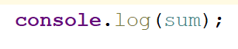

## Even and Odd Subtraction

Write a program that calculates the **difference** between the sum of the even and the sum of the odd numbers in an array.

### Examples

|  |  |  |
| --- | --- | --- |
| **Input** | **Output** | **Comments** |
| [1,2,3,4,5,6] | 3 | 2 + 4 + 6 = 12  1 + 3 + 5 = 9  12 – 9 = 3 |
| [3,5,7,9] | -24 |  |
| [2,4,6,8,10] | 30 |  |

### Hints

First, we receive the **array of strings** and parse them to numbers.



We will need two variables – **even** and **odd** sum.

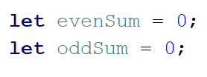

Iterate through all elements in the array with **for-of loop** and check if the number is odd or even.

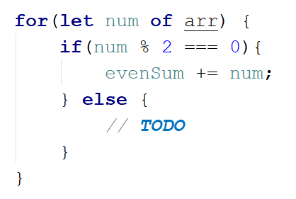

Print the difference.

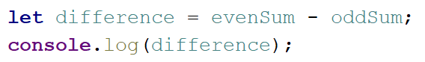

## Equal Arrays

Receive **two** **string arrays** and print on the console whether they are **identical** or not.

Arrays are identical if their elements are **equal**. If the arrays are identical find the **sum** of the first one and print on the console following message:

'**Arrays are identical. Sum: {sum}**'

If the arrays are **not identical** find the **first index** where the arrays **differ** and print on the console following message:

'**Arrays are not identical. Found difference at {index} index**'.

### Examples

|  |  |
| --- | --- |
| **Input** | **Output** |
| ['10','20','30'], ['10','20','30'] | Arrays are identical. Sum: 60 |
| ['1','2','3','4','5'], ['1','2','4','4','5'] | Arrays are not identical. Found difference at 2 index |
| ['1'], ['10'] | Arrays are not identical. Found difference at 0 index |

### Hints

First we receive **two** arrays of strings and parse them.

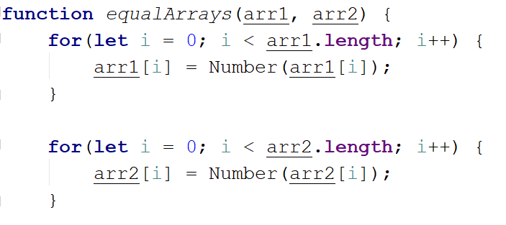

Iterate through the arrays and **compare all element**. If the elements are **not equal** print the required message and break the loop.

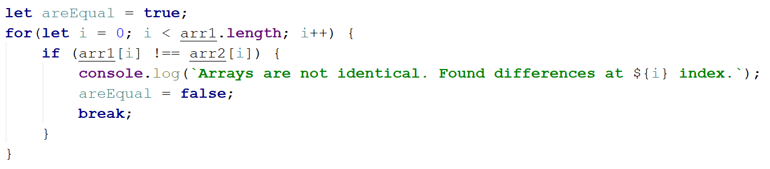

Think about how to solve the other part of the problem.

## Condense Array to Number

Write a program to receive **an array of numbers** and **condense** them by **summing** adjacent couples of elements until a **single number** is obtained.

For example, if we have 3 elements [2, 10, 3], we sum the first two and the second two elements and obtain {2+10, 10+3} = {12, 13}, then we sum again all adjacent elements and obtain {12+13} = {25}.

### Examples

|  |  |  |
| --- | --- | --- |
| **Input** | **Output** | **Comments** |
| [2,10,3] | 25 | 2 10 3 🡪 2+10 10+3 🡪 12 13 🡪 12 + 13 🡪 25 |
| [5,0,4,1,2] | 35 | 5 0 4 1 2 🡪 5+0 0+4 4+1 1+2 🡪 5 4 5 3 🡪 5+4 4+5 5+3 🡪 9 9 8 🡪 9+9 9+8 🡪 18 17 🡪 18+17 🡪 35 |
| [1] | 1 | 1 is already condensed to number |

### Hints

While we have more than one element in the array nums[], repeat the following:

* Allocate a new array condensed[] of size nums.Length-1.
* Sum the numbers from nums[] to condensed[]:
  + condensed[i] = nums[i] + nums[i+1]
* nums[] = condensed[]

The process is illustrated below:

